Problem – Solution Fit
Project Design Phase
Date | 15 February 2025
Team ID | SWTID-2026-1074
Project Name | SB Stocks
Team Size | 5
Team Leader | Venkatesh Illa
Team Members | Durga Meghana Kondempudi, Chandrika Narla, Mogali Shyam, Sravani Jagu
Maximum Marks | 2 Marks

SB Stocks — Problem-Solution Fit

Trigger
Beginners want to understand stock trading but are afraid to risk real capital while learning.

Existing Alternatives
Real broker demo accounts (often require KYC/paid subscriptions), spreadsheets, or generic stock-watching apps with no order simulation.

Emotional Response
Anxiety about loss, frustration with cluttered interfaces, and low confidence to start trading without guidance.

Solution
SB Stocks gives every user a virtual wallet, a simulated live market with 15 NASDAQ-style symbols, and a full Buy/Sell/Portfolio/History workflow secured with JWT authentication — all with zero financial risk.

Channels of Behaviour
Users already check stock apps and wallets daily on mobile and web; SB Stocks mirrors that same familiar Home → Trade → Portfolio → History flow so adoption requires no new habit.
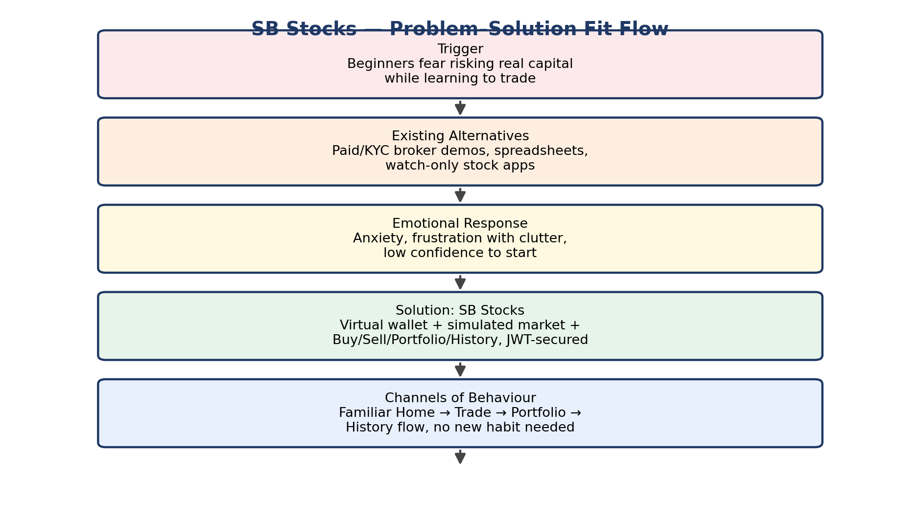
Figure: Problem–solution fit flow for SB Stocks

